International Phonetic Alphabet Game

1. Purpose

Help students practice the IPA symbols, pronunciation, and mouth shapes.

1. Format

Web app

More like a game than a quiz

1. Tools

HTML, CSS (Bootstrap), JS (jQuery)

1. Inspiration

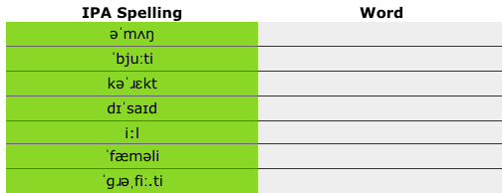

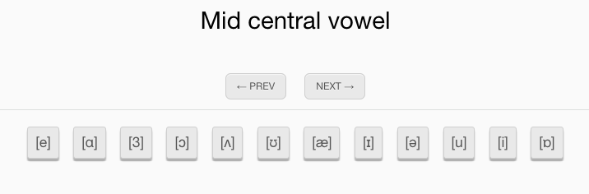

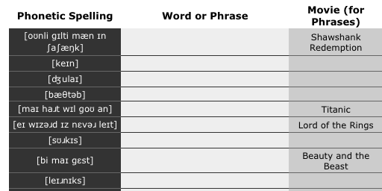

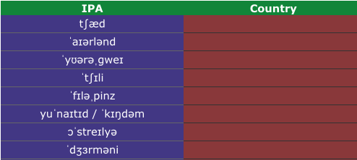

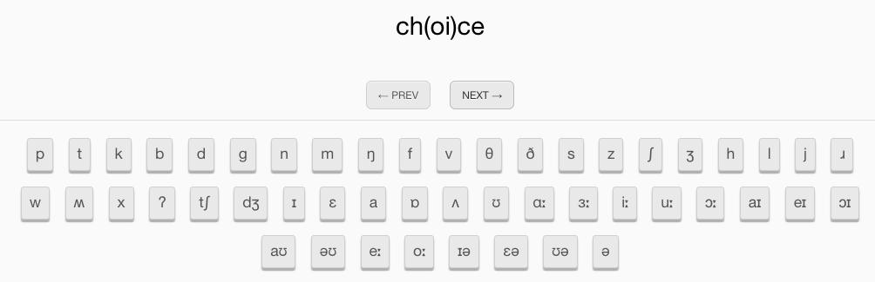

1. Resources

<http://www.worldwidewords.org/pronguide.htm>

<http://ipa.typeit.org/full/>

<http://www.phonemicchart.com/transcribe/1000_basic_words.html>

<https://www.ling.upenn.edu/courses/Fall_2014/ling115/phonetics.html>

<https://en.wikipedia.org/wiki/International_Phonetic_Alphabet_chart>

<http://www.antimoon.com/how/pronunc-soundsipa.htm>

1. Plan

#A3FF92

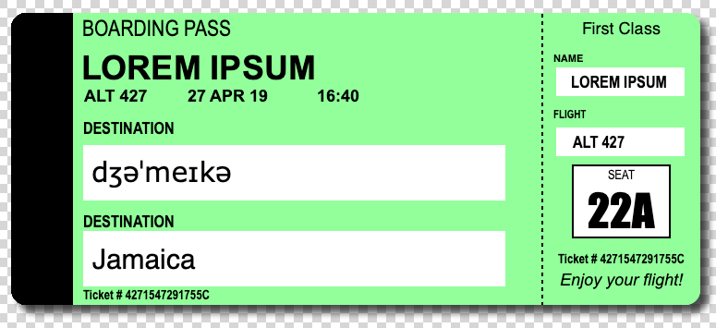

Width 748px Height 317px

Input 78px from left